POWER BI DASHBOARD CHALLENGE

TASK 4 – BASIC DAX MEASURES
● Create aggregation measures such as:
○ SUM → total of a numeric column
○ AVERAGE → mean value of a numeric column
○ COUNT / COUNTROWS → number of records
○ MIN / MAX → smallest and largest values
● ✅ Task: Use these measures in simple visuals (Cards, Tables, Charts).
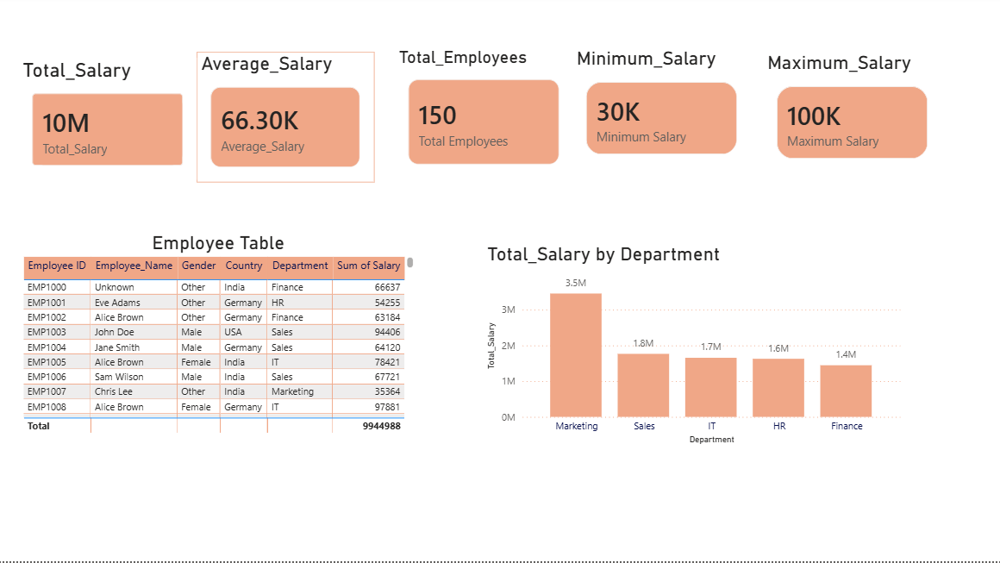
OBSERVATION:
- Total Salary was calculated using the SUM function.
- Average Salary was calculated using the AVERAGE function.
- Total Employees were counted using the COUNT function.
- Minimum Salary was identified using the MIN function.
- Maximum Salary was identified using the MAX function.
- Card visuals displayed important KPIs for quick analysis.
- A table visual provided a detailed view of employee information.
- A chart visual helped compare employee data across different categories.
- DAX measures improved data analysis by summarizing key metrics.
- The report provides a clear and interactive overview of the Employee Details dataset, making it easier to analyze workforce and salary information.

